Task 4

Project: Movie Rental Analysis System (using Redshift or PostgreSQL)

---OLAP Operations---

---Drill Down: Analyze rentals from genre to individual movie level---

-- Starting with the genre summary---

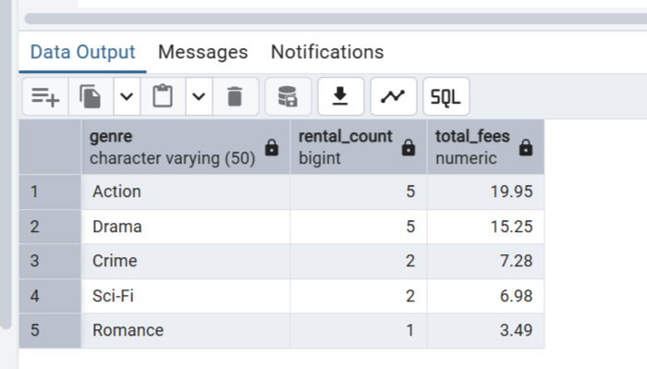

-- Drill down to specific movies in Action genre---

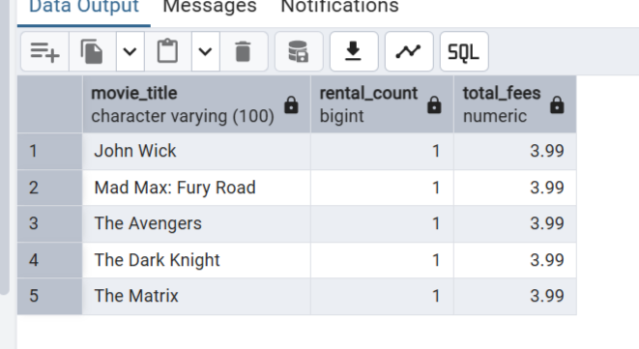

---Rollup: Summarize total rental fees by genre and then overall---

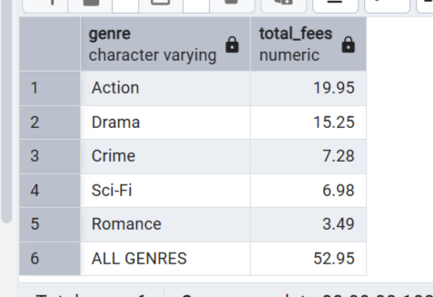

---Cube: Analyze total rental fees across combinations of genre, rental date, and customers---

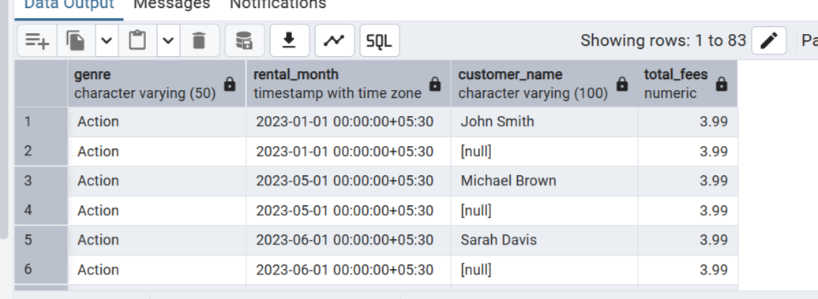

---Slice: Extract rentals only from the ‘Action’ genre---

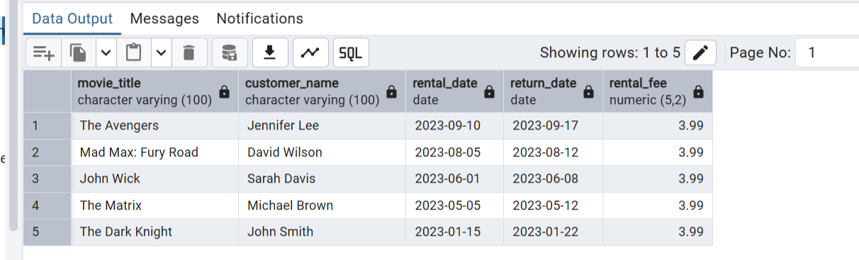

---Dice: Extract rentals where GENRE = 'Action' or 'Drama' and RENTAL_DATE is in the last 3 months---

